Smart Inference Gateway
LLM Cost and Latency Optimization for Kore.ai XO via Custom LLM Integration
Solution Design Document · v1.0 · July 1, 2026 · Author: Mandar

1. Executive Summary
Kore.ai XO invokes a large language model on every conversation turn for intent orchestration, agent-node automation, and RAG answer generation. Analysis of production request logs shows that a substantial share of these calls resolve trivial decisions at frontier-model prices: 3,763 tokens of GPT-4o to classify a one-word user reply, and 6,175 tokens of GPT-4.1 to perform deterministic JSON filtering. This document describes the Smart Inference Gateway: an OpenAI-compatible proxy, deployed on Railway and registered in XO as a Custom LLM per feature, that serves requests through a layered waterfall of deterministic rules, response caching, and fine-tuned small models before falling back to the frontier LLM. The gateway requires zero platform changes, ships in a risk-free shadow mode, records every exchange to a traffic bank that continuously feeds fine-tuning, and exposes per-layer containment metrics that quantify the value delivered. At the initial scale of 5,000 sessions per day (roughly 65,000 orchestrator turns), the projected steady-state impact is a 60 to 80 percent reduction in blended LLM cost and a 70 percent or greater reduction in median turn latency.

2. Problem Statement
The platform architecture routes every conversational turn through one or more LLM calls, regardless of the complexity of the decision being made. Because the platform composes a single large prompt with dynamic variables injected at runtime, three structural inefficiencies compound:
- Trivial decisions at frontier prices. The intent orchestrator, which fires on every turn, consumes thousands of instruction tokens to classify inputs that are frequently one-word confirmations, model numbers, or explicit agent requests whose handling rules are already spelled out verbatim in the prompt itself.
- Deterministic work dressed as generation. Agent-node automations such as driver selection receive structured JSON data and a filtering instruction; the model's output is a verbatim copy of an input record. This is set filtering, not language understanding.
- Defeated provider-side caching. Dynamic content (conversation history, retrieved chunks, dialog state) is injected into the middle of otherwise static prompts, so the provider's automatic prefix caching never engages and the full prompt is billed at the uncached rate on every turn.
Evidence from production logs (June 30, 2026):
Pipeline | Model | Prompt tokens | Cached | Output | Latency
Intent orchestrator (user input: “no”) | gpt-4o | 3,763 | 0 | 33 | ~0.7 s
Driver selection (JSON filter by OS) | gpt-4.1 | 6,175 | 0 | 153 | ~1.5 s
RAG answer generation | gpt-4o | 11,844 | 11,776 | 124 | ~2.4 s

At 5,000 sessions per day with 10 to 15 volleys each, the orchestrator alone generates roughly 65,000 LLM calls daily. Latency stacks across the turn (orchestration precedes generation), degrading user experience on both digital and voice channels, where sub-second turn budgets matter most.

3. Objectives and Constraints

3.1 Objectives
- Reduce LLM token cost materially and measurably, with per-layer attribution suitable for customer-facing value reporting.
- Reduce median turn latency, prioritizing the orchestrator since it executes on every volley.
- Gradually remove LLM reliance using accumulated production traffic, so the system improves as usage grows rather than degrading.
- Remain fully generic: the same chassis must onboard new bots, prompts, and business use cases without re-architecture.

3.2 Constraints
- The XO platform cannot be modified. The only integration surface is the Custom LLM endpoint configuration, which XO supports per feature.
- No self-hosted model infrastructure. Model customization uses the OpenAI hosted fine-tuning service (wizard-driven, no data-science tooling required); serving uses OpenAI serverless endpoints.
- Hosting on Railway (existing subscription), with a persistent volume for the traffic bank.
- English-first rollout with a defined path to LATAM languages (Spanish, Portuguese).

4. Solution Overview
The Smart Inference Gateway is a stateless FastAPI service that presents OpenAI-compatible chat-completion endpoints. Each XO feature is pointed at its own gateway route (/orchestrator, /agent-node, /search, /passthrough), which eliminates any need for the gateway to guess which pipeline a request belongs to. Requests flow through a serving waterfall; whatever cannot be handled locally is forwarded to OpenAI or Azure OpenAI, optionally with the prompt restructured for provider-side prefix caching and the model silently overridden. Every exchange, regardless of which layer served it, is appended to a JSONL traffic bank on a persistent volume.
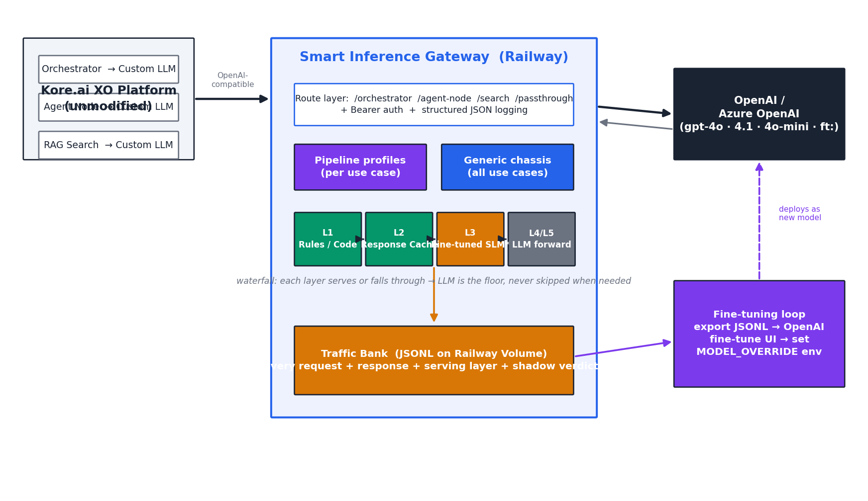
Figure 1. System architecture. XO features connect per-feature to gateway routes; the generic chassis hosts pluggable pipeline profiles; the traffic bank feeds the OpenAI fine-tuning loop, whose output models are deployed back via a single environment variable.

4.1 Serving waterfall
Each route evaluates layers in order and serves from the first layer that produces a confident result. Fabricated responses replicate the OpenAI response schema exactly, including the usage block that XO parses, so the platform cannot distinguish a gateway-served turn from a model-served one.
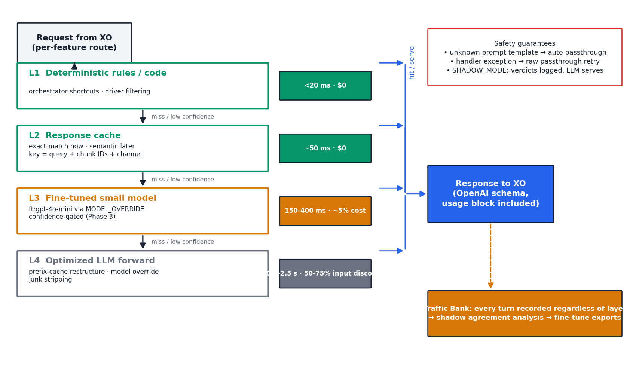
Figure 2. Request lifecycle. Every layer either serves or falls through; the LLM is always the floor. Safety guarantees (right) ensure unknown prompt templates and handler errors degrade to verbatim passthrough, never to failure.
Layer 1, rules and code, encodes only unambiguous decisions: bare confirmations and model numbers during an active dialog, explicit agent-transfer vocabulary, small-talk-only inputs, and deterministic data filtering for agent nodes. Precision is prioritized over recall; anything with the slightest ambiguity falls through. Layer 2 caches answer-generation responses keyed on the normalized query, the retrieved chunk identifiers, and the channel, so a knowledge-base re-index automatically invalidates stale entries. Layer 3, introduced in Phase 3, is a fine-tuned gpt-4o-mini deployed on OpenAI's serverless infrastructure and enabled by a single environment variable. Layer 4 forwards to the frontier model with two optimizations: the orchestrator prompt is optionally restructured so its two static instruction blocks form a stable, byte-identical prefix (measured at roughly 2,550 tokens against production prompts, comfortably above the 1,024-token threshold for automatic provider caching), and known junk such as serialization artifacts is stripped.

5. Generality: Chassis and Pipeline Profiles
The solution is intentionally split into a generic chassis and per-use-case pipeline profiles. The chassis, roughly seventy percent of the codebase, is entirely use-case agnostic: routing, authentication, structured logging, shadow-mode execution, the cache backend, the upstream client, error recovery, metrics, the traffic bank, and the fine-tuning export. None of it references any specific bot, prompt, or business domain.
Pipeline profiles are the use-case-specific extractors and vocabularies: which regex identifies the dialog context in a given prompt template, which keywords constitute an agent-transfer request for a given customer, which JSON schema a verdict must replicate, and where a template's static and dynamic segments begin and end. The initial profiles target the three pipelines evidenced in the analyzed logs, but the pattern generalizes: onboarding a new bot or a new use case means authoring a new profile against its prompt template, not modifying the chassis.
This anchoring to specific templates is also the core safety mechanism rather than a limitation. An extractor that fails to match a prompt, because the template changed or belongs to a different bot, causes an automatic fall-through to verbatim LLM passthrough. The gateway can therefore never misfire on traffic it was not explicitly taught to handle; the worst case is always today's behavior. The planned evolution is to lift profiles out of code into per-route configuration (declarative extraction patterns, rule vocabularies, and verdict schemas), enabling profile authoring for new customers without redeployment.

6. Rollout and Continuous Improvement
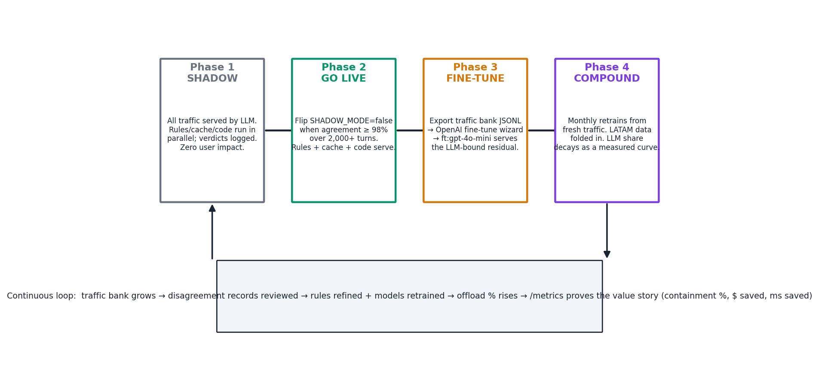
Figure 3. Phased rollout. Shadow mode measures risk-free; go-live is gated on measured agreement; fine-tuning converts accumulated traffic into progressively cheaper serving; the loop compounds monthly.
The gateway ships with shadow mode enabled: rules, code matching, and cache lookups execute and log their verdicts on every request, but the LLM serves all traffic. Users experience zero change while the gateway accumulates agreement statistics. Go-live for local serving is gated on a measured threshold, at or above 98 percent verdict agreement over at least 2,000 orchestrator turns, with every disagreement record reviewed beforehand. At the projected volume this evidence accumulates within two to three days.
Fine-tuning follows once the traffic bank holds several thousand LLM-labeled examples (roughly one week of traffic). The export script converts bank records into OpenAI's fine-tuning JSONL format with deduplication and schema validation; the OpenAI web wizard handles training; deployment is a one-variable change (ORCH_MODEL_OVERRIDE). Two training variants are supported: a drop-in variant that preserves the full prompt, and a stripped variant that bakes the static instruction blocks into the model weights, cutting per-turn input tokens by roughly 80 percent. LATAM expansion folds Spanish and Portuguese traffic into subsequent training runs; language-sensitive rules remain English-gated until equivalent vocabularies are validated.

7. Expected Impact
Projection for the orchestrator pipeline at 65,000 calls per day, using observed token counts and current OpenAI list pricing:
Stage | Mechanism | Est. monthly cost | Typical latency
Today (baseline) | gpt-4o, zero cache hits | ~$18K | ~700 ms
Phase 2a: prefix restructure | ~2.5K tokens cached at 50% discount | ~$10K | ~500-700 ms
Phase 2b: + rules serving | ~40% of turns served locally | ~$6K | 10 ms (rule) / 700 ms
Phase 3: fine-tuned 4o-mini | stripped prompt, ~800 input tokens | < $1K | 150-400 ms

The agent-node pipeline approaches zero marginal cost for well-formed queries served by code matching; validated against production logs, the code path reproduced the frontier model's driver selection exactly. The answer-generation pipeline benefits from response caching (support-domain queries repeat heavily) and from a model-tier A/B test enabled by the per-route override. All containment is reported live at the /metrics endpoint, providing the per-layer numbers (offload percentage, shadow agreement percentage) that anchor the customer value story.

8. Risks and Mitigations
Risk | Mitigation
Rule or cache serves a wrong answer | Shadow mode gates go-live on measured ≥98% agreement; rules encode only decisions the prompt itself specifies verbatim; every verdict is schema-validated before serving.
Prompt template changes in XO | Extractors anchor on template markers; a non-match causes automatic verbatim passthrough. Bank records flag the fingerprint change for profile updates.
Stale cached answers after KB updates | Cache keys embed retrieved chunk identifiers; re-indexing changes the key and forces a miss. TTL bounds worst-case staleness.
Gateway outage | Railway healthcheck with auto-restart; instant rollback available by repointing any XO feature to the original provider configuration, with no code change.
Fine-tuned model regression | Shadow comparison before traffic shift; single-variable rollback; monthly retrains reviewed against held-out disagreement records.
Data at rest on gateway volume | Traffic bank supports a slim mode (verdicts only, no bodies); volume access restricted to the service; retention window configurable per customer requirement.

9. Operations Summary
The gateway is configured entirely through environment variables (upstream provider and keys, per-route feature flags, per-route model overrides, cache TTL, traffic-bank mode, log level), enabling behavior changes without redeployment. All logs are single-line JSON objects on stdout, filterable in Railway's log explorer by route, serving layer, request identifier, and shadow-agreement outcome. The /healthz endpoint drives the platform healthcheck; /metrics exposes per-route, per-layer counters including offload and shadow-agreement percentages. Full deployment steps, the complete variable reference, and the operating playbook are maintained in the repository README.

